Healthcare Professional Information

Musculoskeletal Pain Management
Compounded Topical Options for Localised Musculoskeletal Pain
Prescriber information - healthcare professionals only
Important: Compounded topical analgesic therapy should be considered only after appropriate clinical assessment, diagnosis, review of red flags, medication history, comorbidities, allergy status, pregnancy status, renal function where clinically relevant, and treatment goals. Compounded products should be prescribed where a commercially available product is unsuitable for the patient's clinical need, required strength, formulation preference, tolerability, adherence or individualised management plan.
Suggested use: restricted clinician-only webpage, downloadable prescriber information sheet, or GP discussion handout.

Executive summary
Localised musculoskeletal pain is common in general practice and may involve inflammation, soft-tissue strain, myofascial pain, muscle tightness, posture-related overload or spasm-associated discomfort.
Topical non-steroidal anti-inflammatory drugs, including ketoprofen and diclofenac, have the strongest evidence among topical pharmacological options for acute musculoskeletal pain such as sprains, strains and overuse injuries. Compounded multi-ingredient creams may be considered where a prescriber requires individualised therapy, but evidence for some compounded adjuncts, including topical cyclobenzaprine, baclofen and multi-drug combinations, remains limited.
Heywood Compounding can prepare prescriber-directed topical options for selected patients with localised muscular pain, neck and shoulder discomfort, posture-related strain, or spasm-associated pain where standard commercial options are unsuitable or insufficient.
Evidence snapshot: topical NSAIDs for acute musculoskeletal pain
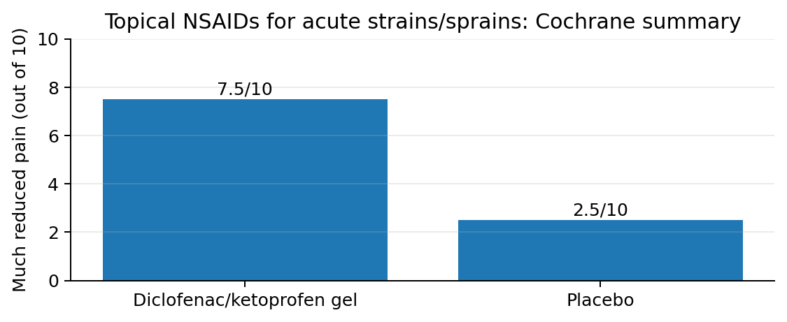
Figure 1. Approximate patient-level response summary from Cochrane review: diclofenac/ketoprofen gels vs placebo after 7 days in acute strains, sprains or muscle pulls.

Clinical context
Musculoskeletal pain may arise from:
- Local soft-tissue inflammation
- Muscle strain or overuse
- Myofascial trigger-point pain
- Postural overload
- Neck and shoulder tension related to prolonged device or computer use
- Protective muscle tightness or spasm
- Mixed nociceptive and neuropathic features
Topical therapy may be considered when the pain is localised, the target area is accessible, and the prescriber wishes to reduce reliance on systemic analgesics or oral NSAIDs. It should usually be combined with non-pharmacological management such as rest, graduated movement, stretching, posture correction, ergonomic modification and physiotherapy where appropriate.

1. Muscular pain

Compounding treatment option
Ketoprofen 10-15% + Camphor 3% + Menthol 5% Cream

Suggested clinical positioning
This formulation may be considered for selected patients with localised muscular pain, soft-tissue strain, overuse-related discomfort or inflammatory musculoskeletal pain where topical NSAID therapy is clinically appropriate and NSAIDs are tolerated.

Ingredient rationale
Ingredient | Intended role | Prescriber notes
Ketoprofen 10% | Topical NSAID / anti-inflammatory analgesic | Provides the main anti-inflammatory and analgesic component. Consider NSAID contraindications and caution factors even though systemic exposure is generally lower than with oral NSAIDs.
Camphor 3% | Counter-irritant / sensory effect | May provide a warming/cooling sensory effect and short-term symptomatic relief.
Menthol 5% | Counter-irritant / cooling analgesic effect | May provide rapid cooling sensation and short-term symptomatic relief.

Suggested directions
Apply a thin layer to the affected area two to three times daily for up to 14 days, then review response and tolerability.

Clinical notes
This option is best framed as a localised muscular pain / soft-tissue pain formulation. Menthol and camphor may provide early sensory relief, while ketoprofen provides the anti-inflammatory component. Avoid claiming guaranteed rapid transdermal action or superiority over commercial products unless supported by specific formulation data.

2. Neck and shoulder pain / posture-related strain / pain with spasm

Clinical context
Neck and shoulder pain are increasingly recognised in association with sedentary and screen-based lifestyles. Prolonged smartphone or computer use may contribute to forward-head posture, sustained cervical flexion, upper trapezius and levator scapulae overload, myofascial tenderness and spasm-associated discomfort.
Evidence supports an association between smartphone overuse and neck pain, although posture and device use should be considered contributing factors rather than the sole cause. Management should include ergonomic advice, movement breaks, posture correction, stretching, strengthening and physiotherapy where appropriate.

Compounding treatment option
Ketoprofen 10 to 15% + Cyclobenzaprine HCl 1% + Camphor 3% + Menthol 5% Cream

Suggested clinical positioning
This formulation may be considered for selected patients with localised neck and shoulder discomfort where soft-tissue inflammation, postural strain and muscle tightness or spasm-associated pain are suspected.

Ingredient rationale
Ingredient | Intended role | Prescriber notes
Ketoprofen 10% | Topical NSAID / anti-inflammatory analgesic | Main evidence-supported component for localised musculoskeletal pain.
Cyclobenzaprine HCl 1% | Muscle-relaxant-style adjunct | Included where muscle tightness or spasm-associated discomfort is suspected. Evidence for topical cyclobenzaprine remains limited; use should be regarded as an individualised therapeutic trial.
Camphor 3% | Counter-irritant / sensory effect | May provide early symptomatic sensory relief.
Menthol 5% | Cooling counter-irritant | May provide short-term cooling analgesic sensation.

Suggested directions
Apply a thin layer to the affected neck/shoulder area two to three times daily for up to 14 days, then review.

Physiotherapy and posture correction
For posture-related neck and shoulder pain, topical treatment should be considered supportive rather than definitive. Best outcomes are likely when pharmacological treatment is combined with:
- Physiotherapy assessment where clinically appropriate
- Posture and ergonomic correction
- Regular movement breaks
- Stretching and strengthening of cervical, scapular and thoracic musculature
- Review of workstation setup, pillow position and device habits

Optional addition: Lidocaine HCl 5%

When lidocaine may be considered
Lidocaine HCl 5% may be added where there is prominent local pain sensitivity, trigger-point tenderness, superficial burning pain, allodynia-like symptoms or suspected mixed nociceptive/neuropathic pain.
Example option:
Ketoprofen 10% + Cyclobenzaprine HCl 1% + Lidocaine HCl 5% + Camphor 3% + Menthol 5% Cream

Prescriber notes
Lidocaine may provide additional local anaesthetic support but does not directly treat inflammation or muscle spasm. Use caution with large application areas, broken skin, occlusion, frequent application, frail patients, low body weight patients or concurrent local anaesthetic exposure.

Patient selection
These compounded options may be considered where:
- Pain is localised and accessible for topical therapy
- Oral NSAIDs or oral muscle relaxants are unsuitable or poorly tolerated
- Commercial topical options are inadequate or unsuitable
- The prescriber wants an individualised formulation
- There is a clear review plan
- There are no major contraindications to topical NSAID or local anaesthetic use

Precautions and contraindication considerations
Prescribers should consider caution or avoidance in patients with:
- NSAID allergy or aspirin-sensitive asthma
- Previous severe reaction to ketoprofen, diclofenac, ibuprofen or other NSAIDs
- History of severe photosensitivity reaction, especially with ketoprofen
- Broken, infected, inflamed or eczematous skin at application site
- Pregnancy, especially third trimester
- Significant renal impairment, high systemic NSAID risk or concurrent nephrotoxic medicines
- Peptic ulcer disease, anticoagulant therapy or high bleeding risk
- Frailty, falls risk, glaucoma, urinary retention or high anticholinergic burden where cyclobenzaprine is used
- Concurrent sedatives, tricyclic antidepressants, serotonergic medicines or other centrally acting medicines
- Known allergy or sensitivity to lidocaine, menthol, camphor or formulation excipients
Patients should be counselled to wash hands after application, avoid mucous membranes and eyes, avoid occlusive dressings unless specifically directed, and avoid applying excessive quantities.

Monitoring and review
Suggested review points:
- Pain reduction and functional improvement
- Reduced need for oral analgesics
- Local skin irritation, rash, dermatitis or photosensitivity
- Drowsiness, dizziness or anticholinergic symptoms if cyclobenzaprine exposure is suspected
- Numbness, tingling, systemic local anaesthetic symptoms or excessive lidocaine exposure
- Ongoing need beyond the initial 7-14 day trial
If symptoms persist, worsen, radiate, are associated with neurological deficit, trauma, fever, unexplained weight loss, night pain or red flags, further medical assessment is required.

Suggested prescription examples
Clinical use | Example formulation | Suggested directions
Muscular pain option | Ketoprofen 10% + Camphor 3% + Menthol 5% in Cream | Apply thinly to affected area two to three times daily for up to 14 days. Quantity: 50 g. Review if not improving.
Neck and shoulder / spasm-associated option | Ketoprofen 10% + Cyclobenzaprine HCl 1% + Camphor 3% + Menthol 5% in Cream | Apply thinly to affected neck/shoulder area two to three times daily for up to 14 days. Quantity: 50 g. Review response and tolerability.
Mixed pain / local tenderness option | Ketoprofen 10% + Cyclobenzaprine HCl 1% + Lidocaine HCl 5 % + Camphor 3% + Menthol 5% Cream | Apply thinly to affected area two to three times daily for up to 14 days. Quantity: 50 g. Review response and tolerability.

Evidence summary
Topical NSAIDs have the strongest evidence base among topical options for acute musculoskeletal pain. Cochrane evidence indicates that topical NSAIDs provide good pain relief in acute musculoskeletal conditions such as sprains, strains and overuse injuries, with diclofenac and ketoprofen gel among the better-supported preparations.
The evidence for compounded multi-ingredient pain creams is more limited. A randomised controlled trial of compounded topical pain creams for localised chronic pain did not demonstrate meaningful benefit over placebo overall. Therefore, compounded multi-ingredient creams should be positioned as prescriber-directed individualised trials rather than proven first-line treatments.
Smartphone and screen-based behaviours are associated with neck pain in several observational studies and systematic reviews. However, the relationship is multifactorial, involving physical activity, sedentary time, sleep quality, ergonomics, psychosocial factors and posture. Topical therapy should be used alongside posture correction, movement strategies and physiotherapy where appropriate.

References and source notes
- Derry S, Conaghan P, Da Silva JAP, Wiffen PJ, Moore RA. Topical NSAIDs for acute musculoskeletal pain in adults. Cochrane Database of Systematic Reviews. 2015. DOI: 10.1002/14651858.CD007402.pub3.
- Derry S, et al. Topical NSAIDs for acute musculoskeletal pain in adults. PubMed PMID: 26068955.
- Brutcher RE, Kurihara C, Bicket MC, et al. Compounded Topical Pain Creams to Treat Localized Chronic Pain: A Randomized Controlled Trial. Annals of Internal Medicine. 2019;170(5):309-318. DOI: 10.7326/M18-2736.
- National Academies of Sciences, Engineering, and Medicine. Compounded Topical Pain Creams: Review of Select Ingredients for Safety, Effectiveness, and Use. Washington, DC: The National Academies Press; 2020.
- Chen YJ, Hu CY, Wu WT, et al. Association of smartphone overuse and neck pain: a systematic review and meta-analysis. Postgraduate Medical Journal. 2025;101(1197):620-626. DOI: 10.1093/postmj/qgae200.
- Clinicians should also refer to local prescribing requirements, product information, APF guidance, professional standards and patient-specific clinical judgement.
Disclaimer: This document is provided for healthcare professional discussion only. It does not replace independent clinical judgement, local prescribing requirements, product information, physiotherapy assessment or specialist advice. Final prescribing decisions, dose selection, monitoring and review remain the responsibility of the treating prescriber.

